ASSIGNMENT 1: KERNEL MODULE INSERTION

INTRODUCTION :
What is a Kernel module : modules are the pieces of the code that can be loaded and unloaded into the kernel upon demand. They extend the functionality of the kernel without the need to reboot the system. For example one type of module is the device driver, which allows the kernel to access hardware connected to the system.
Without modules we would have to build monolithic kernels and add new functionality directly into the kernel image .

C CODE :

//Passing arguments to the kernel module

//hello.c : simplest kernel module code

#include <linux/init.h>
#include <linux/module.h>
//step1
//#include <linux/moduleparam.h>
//step2 create a variable
static int hello_init(void){
//purpose of the above function is to register functionalities and allocate resources
printk(KERN_ALERT "TEST: Hello world,this is kmodule code which is inserted by CHAITANYA\n");//KERN_ALERT is used for prioritising the log information
//display();
return 0;
}
static void hello_exit(void){
//purpose is to unregister functionalities & deallocate resources
printk(KERN_ALERT "TEST:Good byte,from introductory kmodule code\n");
}
module_init(hello_init);//jump to the execution state
module_exit(hello_exit);//jumps to exit state

MAKE FILE:

obj-m += hello.o

KDIR = /usr/src/linux-headers-4.13.0-39-generic

all:
$(MAKE) -C $(KDIR) SUBDIRS=$(PWD) modules

clean:
rm -rf *.o *.ko *.mod.* *.symvers *.order

OUTPUT :

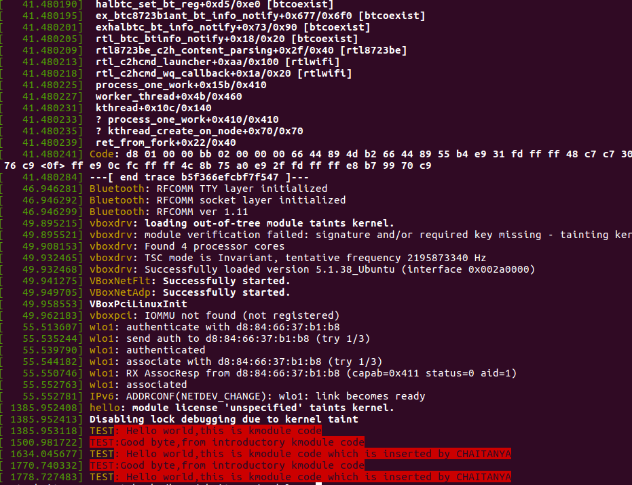
COMPILING STEPS :
make
successful make outputs as follows :
make -C /usr/src/linux-headers-4.13.0-39-generic SUBDIRS=/home/chaitanya/modules modules
make[1]: Entering directory '/usr/src/linux-headers-4.13.0-39-generic'
Building modules, stage 2.
MODPOST 1 module
make[1]: Leaving directory '/usr/src/linux-headers-4.13.0-39-generic'

- this indicates that kernel object file has been built
- now , in supervisory mode the following compilation steps have to be followed
- insmod hello.ko
- dmesg
- rmmod hello.ko

The _init and _exit Macros :
the _init macro causes the init function to be discarded and its memory to be freed once the init function finishes for built-in drivers.
_exit macro causes the ommision of the function when the module is built into the Kernel.

Printk funtion : It acts as a debugging tool for kernel programmers who need this function for logging messages from the kernel.
Each printk statement comes with a priority.

